Nationality：Han

Degree：Master of Science

Birthdate：Feb. 1992

Party identity：League member

Name：Wenke Zhao

Tel：186-2106-3526

Email：1034619148@qq.com

Address：No. 516, Military Road, Yangpu District, Shanghai

**Wenke Zhao**

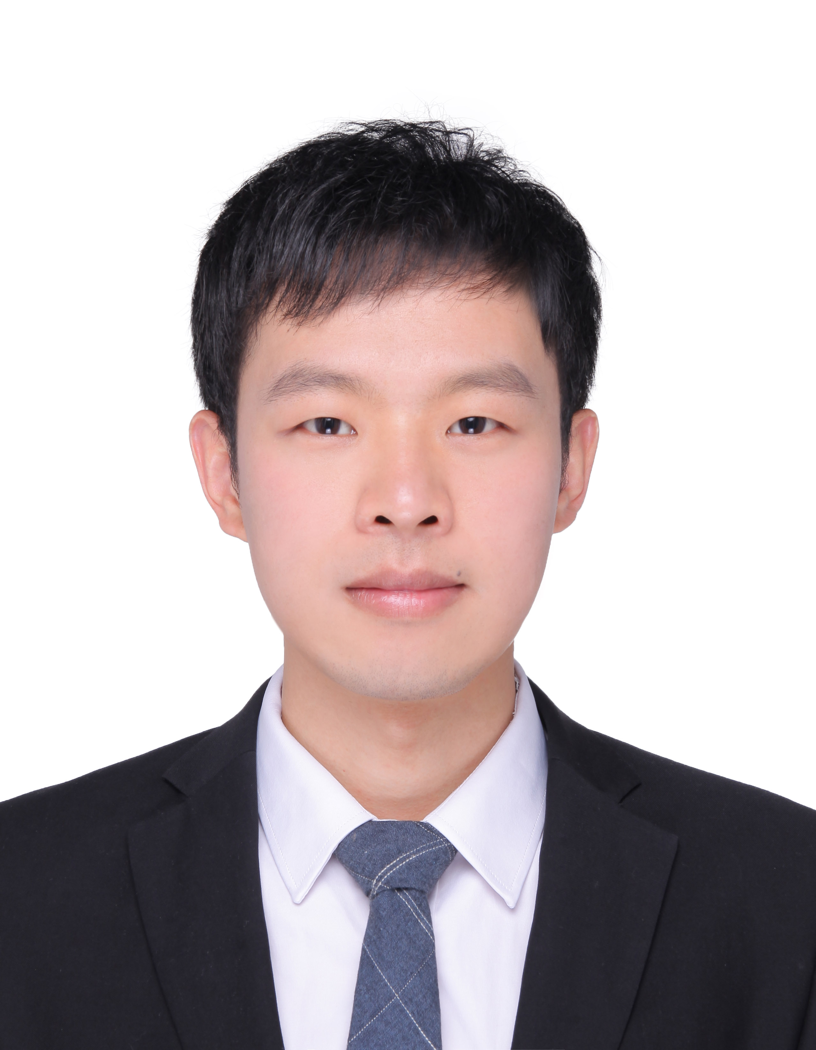

**EDUCATION**

**Sep. 2016-May 2019**

**University of Shanghai for Science and Technolo Master Degree**

Scholastic direction：Pattern Recognition and intelligent system。The paper "Application of Elastic RBF neural network in Face recognition" published in the "Computer Engineering and Software" Journal 39th volume 5th.

Major Courses：Digital image processing, modern digital signal processing and application, advanced algebra, pattern recognition, control system computer aided analysis and design, object-oriented programming C + +, motion controller amplification Circuit design，etc. GPA: 3.3175/4.

**ITEM**

* Feb. 2018 –May 2018：**A remote access control system based on face recognition**。A face detection and recognition system is designed and implemented on mobile device (mobile phone), and data transmission is carried out to control the door lock switch according to the result of recognition. Mainly includes the following work: Image acquisition and preprocessing, face detection and recognition, wireless data transmission, host computer and slave computer communication, lower machine control system design. The main person responsible for face detection and recognition algorithm improvement and program implementation, including image preprocessing, using adaboost algorithm for face detection, based on an improved RBF neural network model for face recognition.

**CONTEST**

* Sep. 2016-Dec. 2016 Participate in "Tang Hui electronic Cup" second China intelligent Instrument Design competition. Entries: **Brain wave signal acquisition and control system**. The experimental platform was built with stm32f103 as microcontroller, combined with Tgam module, Bluetooth module (FBT-06) and l298n DC Motor drive module. The MCU reads, parses and processes the EEG signal through the serial port, MATLAB program receives the data after the MCU processing and returns the classification result, then controls the positive and negative motion of the motor. Mainly participate in the design of MATLAB program.
* Mar. 2017-Jun. 2017 Participate in the third national graduate Mobile Terminal application design innovation competition. Entries: Mobile object multi-function attitude detection system. Based on the MEMS sensor and GPS module, a moving object attitude and position measurement system is designed and implemented. Mainly includes the following aspects of the work, data acquisition and attitude calculation, wireless data transmission, multi-terminal synchronization data acquisition and storage, motion attitude simulation, motion trajectory mapping. It is mainly responsible for attitude calculation and data acquisition and storage design in attitude measurement scheme design.
* In 2017,the third national graduate Mobile Terminal application design innovation competition: second class scholastic.
* In 2017,"Tang Hui electronic Cup" second China intelligent Instrument Design competition: prize for excellence.
* National Inspirational Scholarship, first-class scholarship, etc.

**荣誉奖励**

* As a class publicity member during the postgraduate period, the School patriotic Education Week organized class members to participate in patriotic education activities.
* During the undergraduate period, he served as the Department of Student Inspection minister. Participated in Nanjing Youth Volunteer activities.

**ACTIVITY**

* Proficient in the application of c\c++, MATLAB programming, understand the Python language;
* Familiar with OpenCV library, master commonly used data structure and algorithm knowledge, understand Caffe, familiar with common neural network algorithms such as CNN, BP, RBF, etc.;
* Understand the Linux development environment and understand MySQL;
* Certificate：CET:4；NCRE:2；Intermediate Certificate of CAD；C1 driver's license, Putonghua grade certificate, etc.

**SKILLS**

Participate in the project during the work: wide bandgap semiconductor device driver circuit design, project content: High-power SIC module parallel application and its driving circuit design. Mainly responsible for circuit board alignment design and parasitic parameter analysis and circuit simulation.

**Jul. 2017-Nov. 2017**

**INTER**

**Apr. 2015-Jun. 2015**

**Eaton (China) Investment Co., Ltd. Innovative R & D interns**

Mainly responsible for the Single-chip programming and circuit board line design, work to participate in the completion of a network multi-function instrumentation driver development.

**Wu xi AISNSI Elec. Tech. Ltd. Co. Embedded Software Intern**